**NEW “O” RINGS IN LIDS FOR POUR OFF TUBES**

The pour off tubes now have new “O” rings in their lids. This should make the lids fit more securely. This will hopefully decrease the amount of D9 rejections. A D9 rejection is given for “Individual specimen contamination or gross leakage”. So if a specimen/or specimens leaked in a shipment box, those that were leaked on would be rejected as contaminated. Your site will receive these lids in the next supply shipment when pour off tubes are ordered.

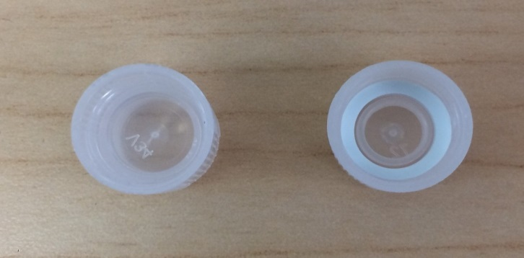

**Old lid (on left) and new “O” ring lid (on right)**

**NEW TEST CODE ORDER 105**

CDD has informed NBIMC that they continue to receive HIV orders using the old Test Code 104. The change from using Code 104 to Code 105 took effect on January 1, 2017. Since CDD cannot process a test code 104 order the orders are automatically rejected.

NBIMC reviewed several Navy hospital sites CHCS screen shots to see how the selection for the Test Code 105 is labeled. All the sites had different ways of labeling their HIV tests.

Please make sure that your CHCS system has removed the choice of ordering a Test Code 104. NBIMC has also noticed that the Navy sites using CHCS have sent the HIV orders to places other than CDD to get tested.

The CHCS selection for the laboratory test of: HIV should be clearly labeled for the test code 105. For example: labeling the test as **HIV-1/2 AG/AB Screen 4TH GEN (Navy/CDD)** so that the lab personnel chooses the correct test order. Making this test order the 1st in the list of choices of tests would also be helpful.

**GREINER SST TUBES**

In our last NBIMC newsletter edition, we discussed that CDD had reverted back to using the Greiner SST tube. This tube has the red top with the inner yellow ring on it. Some sites were shipped the BD tubes during the December 2016 to February 2017 period before CDD reverted back to the Greiner tubes. We stress again to please make sure that your site rotates your stock of tubes by expiration date and not by the brand of tube if you have both brands of tubes in stock.

In March 2017, CDD and Greiner reviewed the guidelines for using the Greiner tube. CDD has received some new information from Greiner regarding the volume required in the tube for testing. Our sites’ D8 and D9 rejections had drastically increased since 2013 while adhering to the Greiner tube old guidelines. There were many sites that due to the increase of D8 rejections (Quantity not sufficient) when using the Greiner tubes started to use the pour off tubes as a way to circumvent getting the D8 rejection. Since the Greiner guidelines have been eased somewhat, CDD and NBIMC are hopeful that the D8 rejections will decrease and also the process of using the pour off tubes to avoid getting a D8 rejection.

**JUST A REMINDER**

* Depending on which tubes your site has (Greiner or BD) there are differences for processing the tubes



* **Next NBIMC Computer downtime is scheduled for:**

**SUNDAY JUNE 25, 2017-from 0700(EST) to 1500(EST)**

**MEMORIAL DAY OBSERVANCE**

NBIMC and CDD’s offices will be closed on Monday May 29th in observance of Memorial Day.

NBIMC would like to extend our sincere thanks to all of our active duty, reservists and veteran military members and their families for all you do and the sacrifices that have been made for all of us. May you enjoy a safe, fun and relaxing holiday weekend.

